AN ANALYSIS OF THE FINAL SEMESTER TEST ITEM DEVELOPED BY THE ENGLISH TEACHER OF SMK KENCANA SAKTI HAUMENI

A THESIS



ASRIT ELUSRY SANAM

ENGLISH EDUCATION STUDY PROGRAM

TEACHER TRAINING AND EDUCATION FACULTY
ARTHA WACANA CHRISTIAN UNIVERSITY
KUPANG
2025
AN ANALYSIS OF THE FINAL SEMESTER TEST ITEM DEVELOPED BY THE ENGLISH TEACHER OF SMK KENCANA SAKTI HAUMENI

A THESIS

ASRIT ELUSRY SANAM
Registered Number: 21130024

ENGLISH EDUCATION STUDY PROGRAM

TEACHER TRAINING AND EDUCATION FACULTY
ARTHA WACANA CHRISTIAN UNIVERSITY
KUPANG
2025
A THESIS

This Thesis is Presented as Partial Fulfilment of the Requirements for the Degree of Sarjana Pendidikan in English Education Study Program

ASRIT ELUSRY SANAM
Registered Number: 21130024

ENGLISH EDUCATION STUDY PROGRAM
TEACHER TRAINING AND EDUCATION FACULTY
ARTHA WACANA CHRISTIAN UNIVERSITY
KUPANG
2025
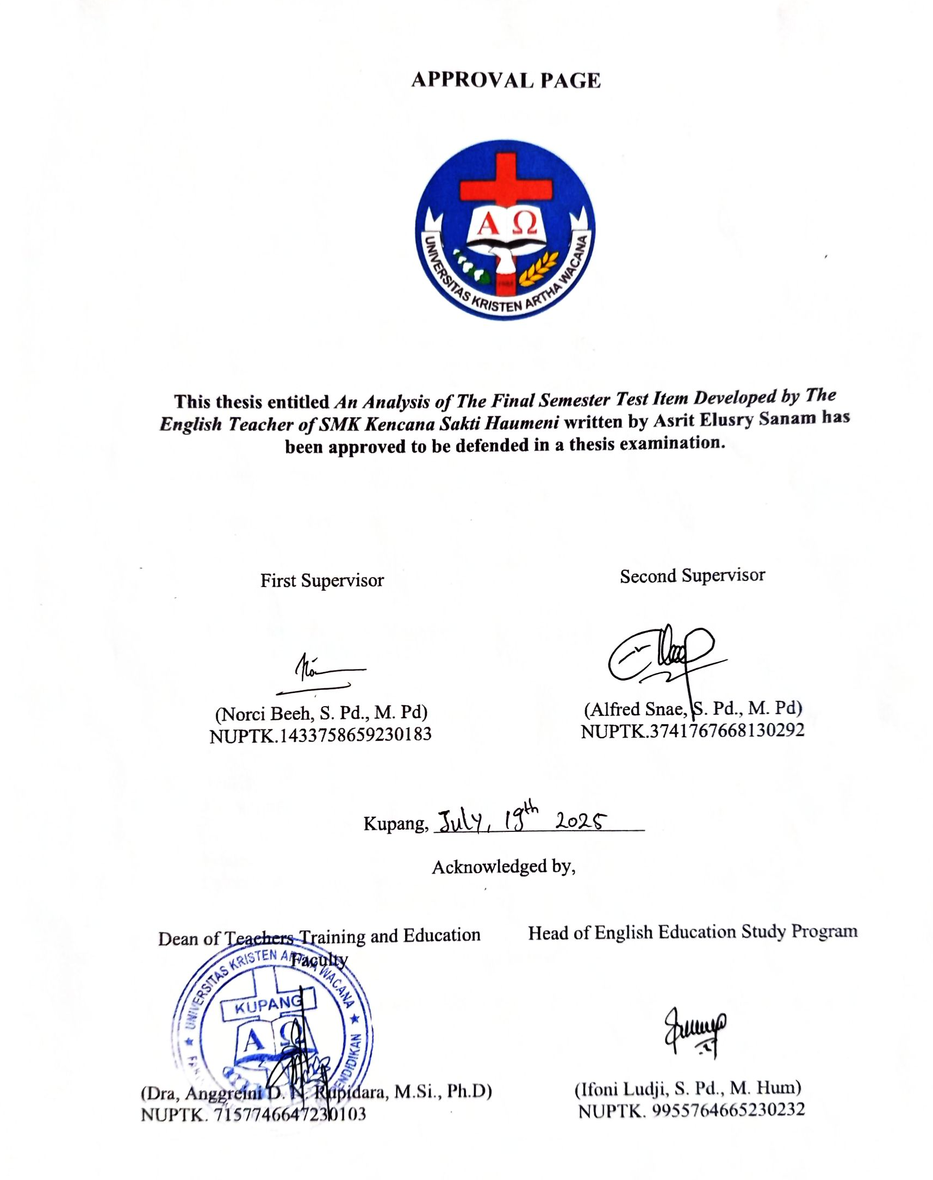
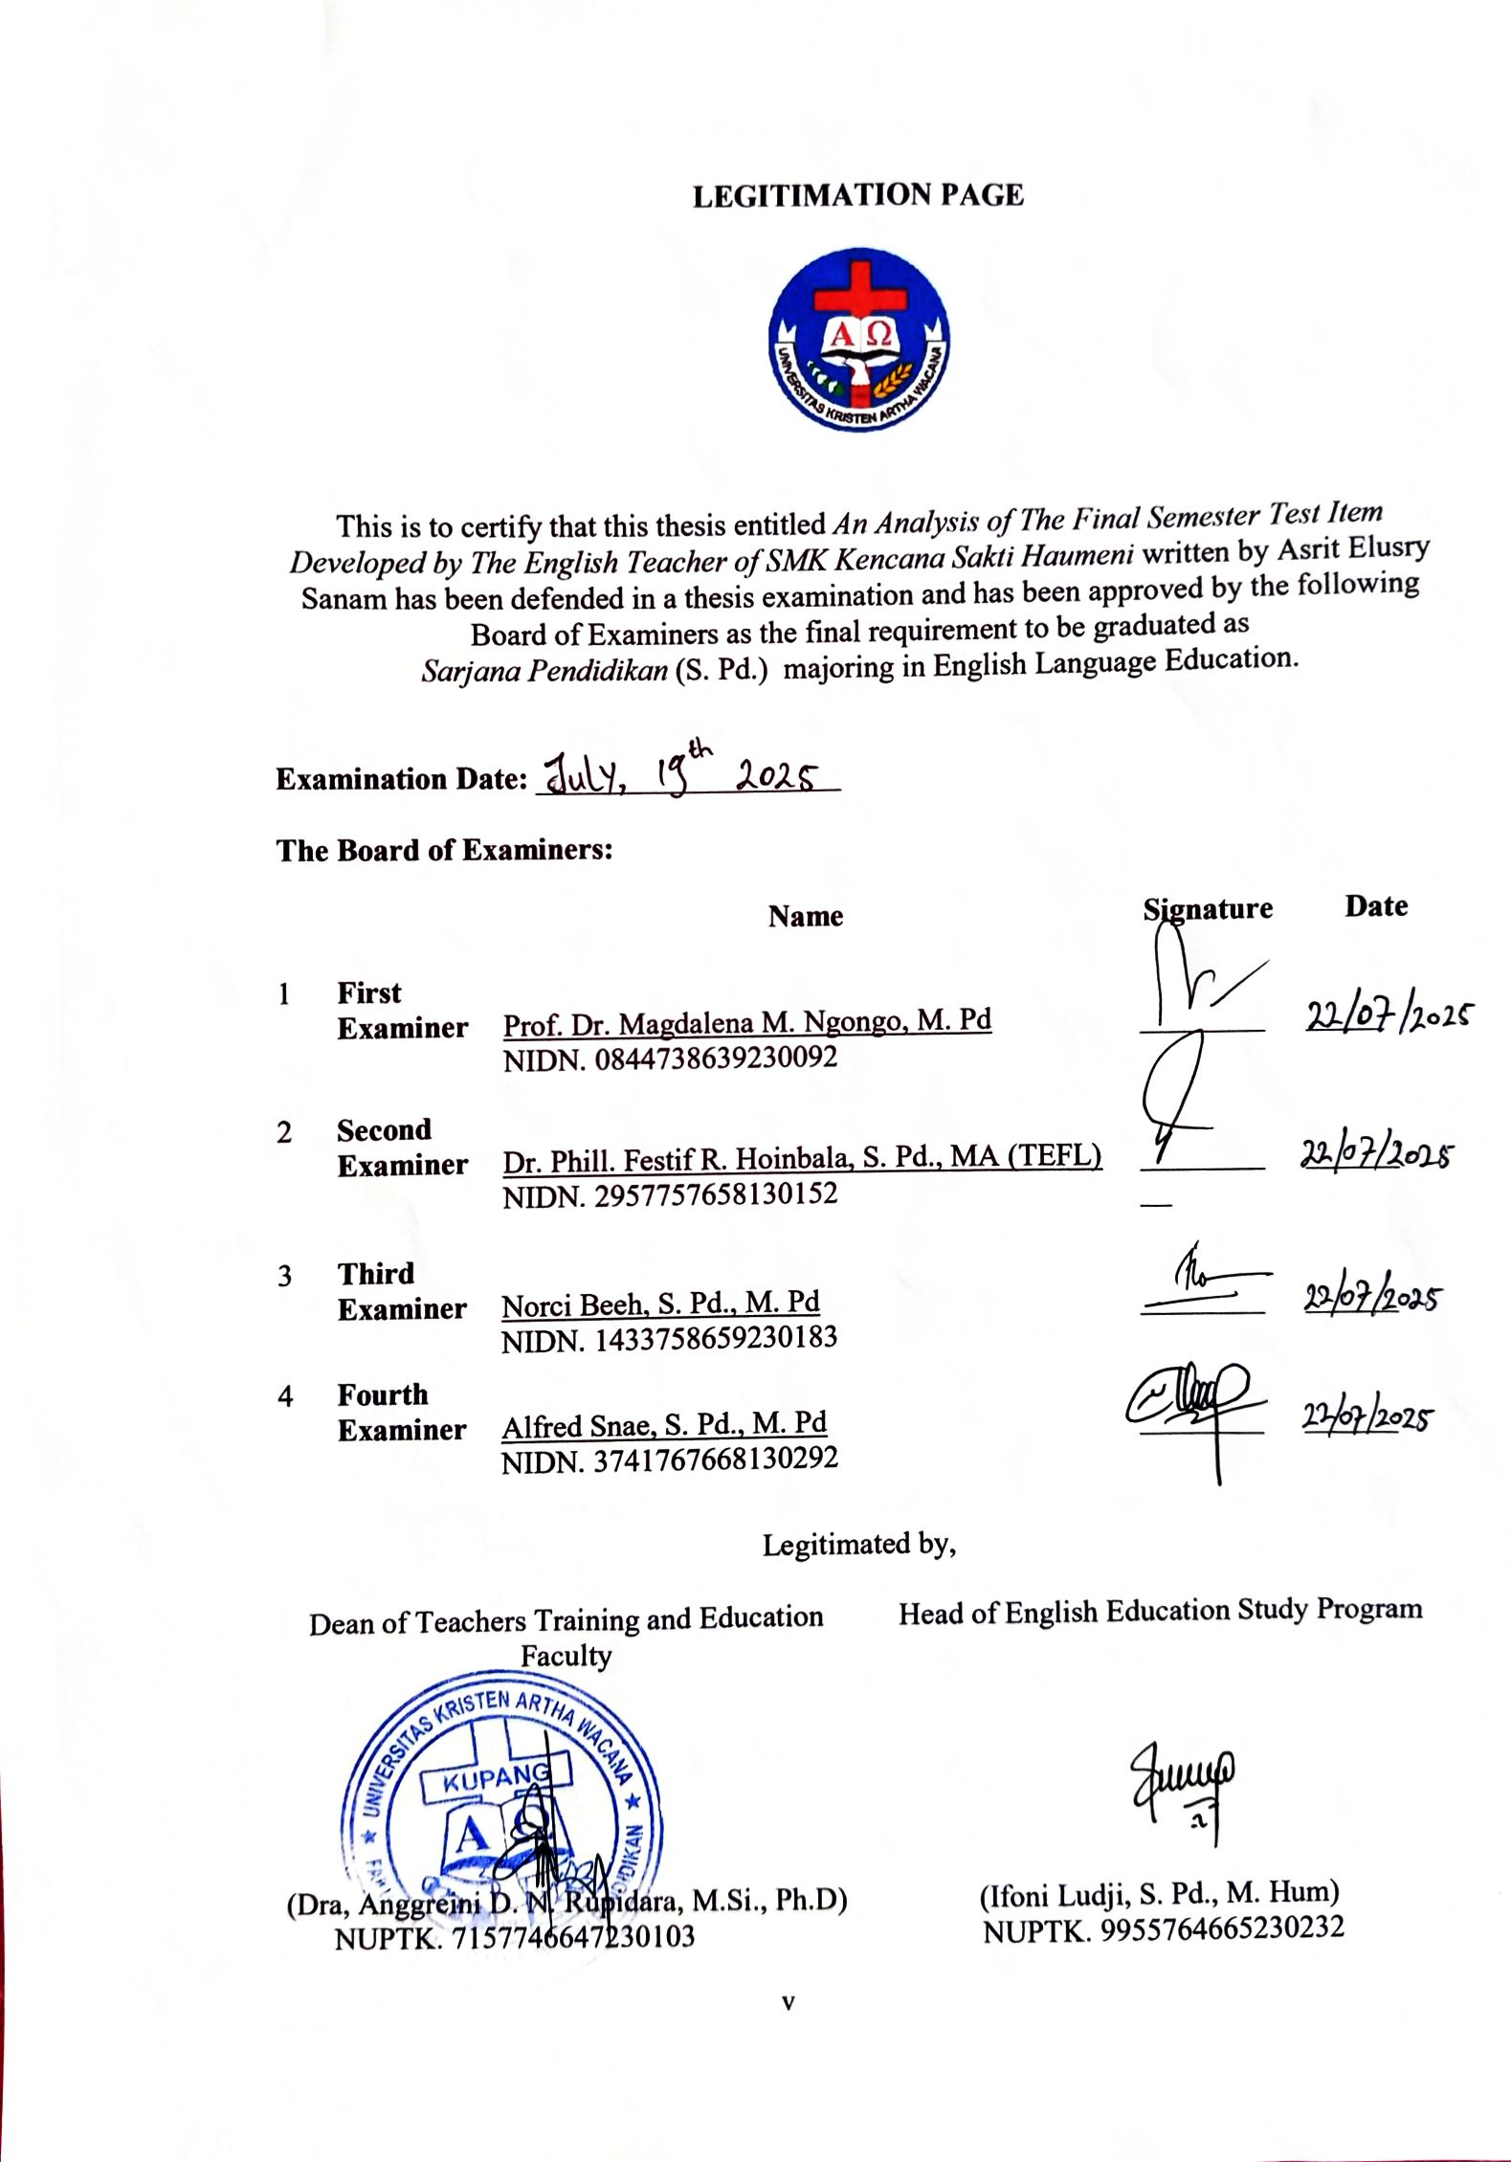

MOTTO

“I can do all things through Christ who strengthens me.”
-Philippians 4:13

PLAGIARISM FREE STATEMENT

The undersigned below
Name  Id Number  Semester  Faculty  Study Program  Thesis Title | :  :  :  :  :  : | Asrit Elusry Sanam  21130024  Eight (VIII)  Teacher Training and Education  English Education  An Analysis of The Final Semester Test Item Developed by The English Teacher of SMK Kencana Sakti Haumeni

I hereby declare that the thesis I am submitting to fulfill the requirements for the Bachelor of Education degree at Artha Wacana Christian University, Kupang, is original and free from plagiarism. If any discrepancies with this statement are found in the future, I am willing to be prosecuted and processed following the provisions of the Minister of National Education Regulation Number 2010.
This statement is made truthfully and is used for the benefit of humanity.
Kupang, August 11, 2025
Asrit Elusry Sanam
Nim: 21130024

DEDICATION

This graduating paper is dedicated to:
- God Almighty, the gratitude and thanks to God Almighty, who always accompanies, guides, hears the writer, and helps the writer in everything to order to finish this study.
- The writer's beloved parents: The writer would like to thank both of my parents, Oni Sanam and Elisabet Nenobais, who always support the writer in all my needs, especially the endless prayers to stay healthy and be able to complete the writer’s studies.
- The writer's beloved brothers, thank you both, Orqi Sanam and Mildon Sanam, who always support the writer to keep trying to finish this study.
- The writer's big family, which always gives motivation.
- Writer’s Alamamater, the private Artha Wacana Christian University.

ACKNOWLEDGEMENT

Praise and gratitude the writer prays to the presence of God Almighty for all His inclusion so that the writer can complete this thesis entitled “An Analysis of The Final Semester Test Item Developed by The English Teacher of SMK Kencana Sakti Haumeni”. This thesis was prepared to fulfil one of the requirements for obtaining a Bachelor of Education degree at the Artha Wacana Christian University Teacher Training and Education Study Program.
The writer realizes that completing this thesis is a long process and can be accomplished. Thank you for all the prayers and support given to the writer. Therefore, on this occasion, the writer would like to thank:
- Prof. Dr. Ir. Godlief Frederik Neonufa, MT, as the chancellor of Artha Wacana Christian University Kupang, has facilitated and provided the opportunity for the writer to study at Artha Wacana Christian University Kupang.
- Dra. Anggreini D. N. Rupidara, M.Si., Ph.D, as the Dean of Teacher Training and Education Faculty at Artha Wacana Cristian University who has allowed the writer to conduct field research.
- Ifoni Ludji, S.Pd., M.Hum, as the head of the English Education Study Program, for her invaluable administrative support and facilitation, which greatly contributed to the smooth progress of this thesis.
- Norci Beeh, S.Pd., M. Pd, as the first supervisor who has given time, thought and energy in providing guidance and direction to the writer in completing this thesis. Additionally, as the academic advisory lecturer who educated, taught, and helped the writer in college.
- Alfred Snae, S.Pd., M.Pd., who provided valuable guidance, direction, and support through his time for consultation, thoughts, and energy as the second supervisor in the completion of this thesis.
- Sincere appreciation is extended to all lecturers of the English Education Study Program who have transferred their knowledge, provided advice, support, and attention during the writer’s studies at Artha Wacana Christian University.
- Gratitude is also conveyed to the principal and teacher of SMK Kencana Sakti Haumeni for granting permission and providing support during the research process.
- Special thanks are given to the writer’s beloved parents, whose prayers and constant encouragement have served as a continuous source of strength.
- Appreciation is expressed to Atalia Robeka Cornelis for her insightful ideas and continuous support during the thesis writing process.
- Thanks are also extended to Novi, Amelia, and Yeland for their consistent assistance and motivation throughout the journey to finish this thesis.
- A heartfelt acknowledgment is extended to Vianty Sabuna for her unwavering support and presence during the completion of this thesis.
- Gratitude is also due to all classmates of SPARTACUS 2021, Class A, for the mutual support and shared spirit.
- Lastly, appreciation is expressed to Artha Wacana Christian University for being a place of academic and personal growth.
Kupang, August 11, 2025
The writer,
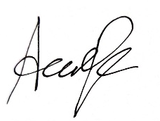

Asrit Elusry Sanam
Finally, the writer can only express gratitude for everything, and she hopes that God will restore everything. Furthermore, the writer hopes that this researcher’s paper will be useful for others. Due to the limited knowledge, constructive criticism and suggestions are needed for the perfection of this graduation paper.

AN ANALYSIS OF THE FINAL SEMESTER TEST ITEM DEVELOPED BY THE ENGLISH TEACHER OF SMK KENCANA SAKTI HAUMENI

ABSTRACT

Asrit Elusry Sanam¹ Norci Beeh² Alfred Snae³

This research is entitled Item Analysis of Final Semester Test Items Developed by English Teacher of SMK Kencana Sakti Haumeni. This study is a small-scale analysis of the items in a summative test created by an English teacher. It examines the quality of multiple-choice items in terms of the difficulty level and discrimination power. This study used a quantitative approach to analyse the quality of the test items through the document analysis of the final semester test items, or summative test, developed by the English teacher and the students' answer sheets. The results show that the summative test contains moderate items, which already meet the criteria, with a ratio of 1.28:2:0.72, whereas the ideal ratio should be 1:2:1 for easy, moderate, and difficult items. In terms of the discrimination power, there are 15 items in satisfactory quality and 11 items in good quality. But there are 20 items of poor quality and 4 items in bad or negative quality for the level of item discrimination. Therefore, the 20 poor items should be revised, and the 4 bad items should be rejected or changed. This research is expected to serve as a reflective means for teachers to evaluate their own tests to ensure the quality of their test items.

Keywords: Item analysis, difficulty level, discrimination power, summative test,

AN ANALYSIS OF THE FINAL SEMESTER TEST ITEM DEVELOPED BY THE ENGLISH TEACHER OF SMK KENCANA SAKTI HAUMENI

ABSTRAK
Asrit Elusry Sanam¹ Norci Beeh² Alfred Snae³

Penelitian ini berjudul Analisis Butir Soal Ujian Akhir Semester yang Dikembangkan oleh Guru Bahasa Inggris SMK Kencana Sakti Haumeni. Penelitian ini merupakan analisis skala kecil terhadap butir soal dalam tes sumatif yang dibuat oleh guru Bahasa Inggris. Penelitian ini menguji kualitas butir soal pilihan ganda dalam hal tingkat kesulitan dan daya pembeda. Penelitian ini menggunakan pendekatan kuantitatif untuk menganalisis kualitas butir soal tes melalui analisis dokumen soal ujian akhir semester, atau tes sumatif, yang dikembangkan oleh guru bahasa Inggris dan lembar jawaban siswa. Hasil penelitian menunjukkan bahwa tes sumatif tersebut memiliki butir soal yang cukup baik dan telah mencapai kriteria dengan perbandingan 1.28:2:0.72, di mana seharusnya perbandingannya adalah 1:2:1 untuk soal yang mudah, sedang, dan sulit. Dari segi daya pembeda, terdapat 15 butir soal dengan kualitas memuaskan dan 11 butir soal dengan kualitas baik. Namun, terdapat 20 butir soal dengan kualitas rendah dan 4 butir soal dengan kualitas negatif untuk tingkat daya pembeda soal. Oleh karena itu, 20 butir soal yang kurang baik harus direvisi dan 4 butir soal yang negatif harus dihilangkan atau diganti. Penelitian ini diharapkan dapat menjadi sarana reflektif bagi para guru untuk mengevaluasi tes yang mereka buat sendiri untuk memastikan kualitas butir soal mereka.

Key words: Analisis butir soal, tes sumatif, tingkat kesukaran, daya pembeda

AUTHOR'S BIOGRAPHY



- Identity  - Name  - Place and Date of Birth  - Address  - Religion  - Phone number  - Email  - Father’s Name  - Mother’s Name | :  :  :  :  :  :  :  : | Asrit Elusry Sanam  Koa, 29 August 2003  Koa, RT.001, RW.001, Mollo Barat Subdistrict, South Central Timor County, East Nusa Tenggara  Protestant  082144817020  Asrid8371@gmail.com  Oni Simus Sanam  Elisabet Nenobais
- Educational Background
- SD Negeri Haususu (2009-2014)
- SMPN Koa 1 Molo Barat (2015-2017)
- SMK Negeri 1 Soe (2018-2020)
- Universitas Kristen Artha Wacana (2021-2025)

TABLE OF CONTENTS

COVER PAGE i
DEGREE PRESTIQUE PAGE ii
APPROVAL PAGE iv
LEGITIMATION PAGE v
MOTTO vi
PLAGIARISM STATEMENT vii
DEDICATION viii
ACKNOWLEDGEMENTS ix
ABSTRACT xi
AUTHOR’S BIOGRAPHY xiii
TABLE OF CONTENTS xiv
LIST OF TABLES xvii
LIST OF CHARTS xviii
LIST OF ABBREVIATIONS xix
CHAPTER 1 INTRODUCTION
  - Background 1
  - Research Problems 3
  - Aims of Study 3
  - Significance of Study 4
    - Implication 4
    - Application 4

CHAPTER II LITERATURE REVIEW, CONCEPT AND THEORETICAL FRAMEWORK
  - Literature Review 6
  - Concept 8
    - Item Analysis 8
    - Final Semester Test 9
    - Criteria of Good Test 9
  - Theoretical Framework 11
    - Multiple-Choice Test Item 11
    - Criteria of Multiple-Choice Item 12
    - Item Analysis 14
CHAPTER III RESEARCH DESIGN
  - Research Design 18
  - Research Locus 19
  - Type and Data Research 19
  - Data Collection Technique and Research Instrument 19
  - Research Procedures 20
  - Data Analysis 20
CHAPTER IV FINDINGS AND DISCUSSION
  - Findings 23
    - Difficulty Level of Summative Test Items at SMK Kencana Sakti Haumeni 24
    - Discrimination Power of Summative Test Items at SMK Kencana Sakti Haumeni 26
  - Discussion 27
    - Difficulty Level 28
    - Discrimination Power 31
CHAPTER V CONCLUSION AND SUGGESTION
  - Conclusion 38
  - Suggestion 39
BIBLIOGRAPHY
APPENDICES

LIST OF TABLES

Table 2.1 The Category of Item Difficulty 16
Table 2.2 The Categorize of Discrimination 17
Table 4.1 The Results of Facility Value of Each Item 25
Table 4.2 The Results of Discrimination Power of Each Item 27
Table 4.3 The Difficulty Level and Discrimination Power of Item Number 6 29
Table 4.4 The Difficulty Level and Discrimination Power of Item Number 12 30
Table 4.5 The Difficulty Level and Discrimination Power of Item Number 7 33
Table 4.6 The Difficulty Level and Discrimination Power of Item Number 45 34
Table 4.7 The Score of Upper and Lower Group 44
Table 4.8 Format of Item Analysis of the English Summative test 44
Table 4.9 The Tabel of Students’ Answer Sheets 63

LIST OF CHARTS

Chart 4.1 The Results of Difficulty Level 24
Chart 4.2 The Results of Discrimination Power 26

LIST OF ABBREVIATION

DL: DIFFICULTY LEVEL
DP: DISCRIMINATION POWER
FV: FACILITY VALUE

